“MOTION DETECTION”
Submitted in partial fulfillment of the requirement for the awards of degree of
Bachelors of Technology
in
Computer Science & Engineering
(Batch: 2017-21)



Submitted by:
Sachin
----------------------------------------------------------------------------------------------------
KIIT College of Engineering, Gurgaon
(Affiliated to MDU, Rohtak, Approved by AICTE, New Delhi)

CANDIDATE’S DECLARATION

I Sachin declare that the work presented entitle “MOTION DETECTION” submitted in the Department of Computer Science & Engineering, , Kiit college of engineering, gurgaon in the partial fulfillment of the requirement for the award of degree of Bachelor of Technology in Computer Science & Engineering is an actual record of my training carried out during Semester 7th at DUCAT ACADEMY, under the supervision/guidance of Tushar.

The matter embodied in this work has not been submitted elsewhere by anyone for award of any other degree.
Sachin

ACKNOWLEDGEMENT
I am highly grateful to Dr. Vikram Professor cum Associate Dean, Faculty of Engineering & Technology, SGT University,Budhera,Gurugram for providing this opportunity to carry out the present report/ work. The constant guidance and encouragement received from Sachin our project teacher-in-charge, Ducat Training Centre, Gurugram, has been of great help in carrying out the present work and is acknowledged with reverential thanks. Without the wise counsel and able guidance, it would have been impossible to complete the report in this manner.
I am also grateful, Atul Kumar forgiving us the necessary facilities to carry out our project work successfully and for providing timely support ,information during the completion of this project.
I would like to thank all our friends for their help and constructive criticism during our project work. Finally, I have no words to express our sincere gratitude to our parents who have shown us this world and for every support they have given us.

Sachin

CERTIFICATE

This is to certify that the project report entitled “MOTION DETECTION“ being submitted by Mr. Sachin in partial fulfillment for the award of the Degree of Bachelor of Technology in Department of Computer Science and Engineering
to Kiit college of engineering is a record of bonafied work carried out by him/her under my guidance and supervision during Semester 7^{h}(2021).
The results embodied in this project report have not been submitted to any other University or Institute for the award of any Degree or Diploma.

Dr. Atul Kumar
Professor
B.TECH COMPUTER SCIENCE
KIIt college of engineering ,GURUGRAM

TABLE OF CONTENTS
- Introduction
- Problem statemenet
- Objectives
- Methodology
- About python
- Open CV
- Applications
- Hardware and Software requirements
- Extra Modules to import
- Background Subtraction
- SMTP
- Source code and implementation:-
- User_details
- Motion detection
- Motion detection for pass word breaching
13. Use Case Diagram
14. Flow Chart
15. Conclusion
16. References

INTRODUCTION

In this running world, there is a growing demand for software systems that are able to detect the object motion.
We can use lot of sectors where the demand for such software would be growing such as security systems That can be automated to detect object motion to provide access to the device or search for criminals in public places
In this we will build a program that will detect the motion using opencv and python and notify the owner about the activity through a mail using gmail. The video will be captured through web camera.
The program will also click some pictures of the activity and send a picture with an alert mail as attachment to the mail id of the owner provided.
The other pictures of the activity are stored in a folder in the system on which the program is executing.

PROBLEM STATEMENT
Over the past decade their have been several improvements in the field of computer science that have completely revolutionized our world.
The multi-touch technology is an emerging technology that revolutionizes the way human interact with machine for infotainment applications.
Motion detection is breaking into a wide range of industries, with use cases ranging from personal security to productivity in the workplace.
Motion detection and recognition is applied in many areas of computer vision, including image retrieval, security, surveillance, automated vehicle systems and machine inspection.
Significant challenges stay on the field of motion recognition. The possibilities are endless when it comes to future use cases for motion detection

OBJECTIVE
- Application Graphical User Interface Created
- Successfully collected image via Web Camera for processing
- To build a program that will detect motion through web cabm using opencv and python.

4.To build a program that sends a mail using smtp .
5.Combine the above two programs to form the motion detector that notifies user.
METHODOLOGY
- Creating requirements specification for the project.
- Determining the various modules within the program.
- Preparing the PERT chart to determine the timeline for the completion for this project.
- Writing the code for the program.

Following are the steps that show the execution of the program:-

- User selects the button to take the image form the web cam.
- The application activates the web Cam to take the image of user face.
- Debugging the program based on the results from the testing.
- Preparing the final year report for the End-Semester presentation.

PYTHON

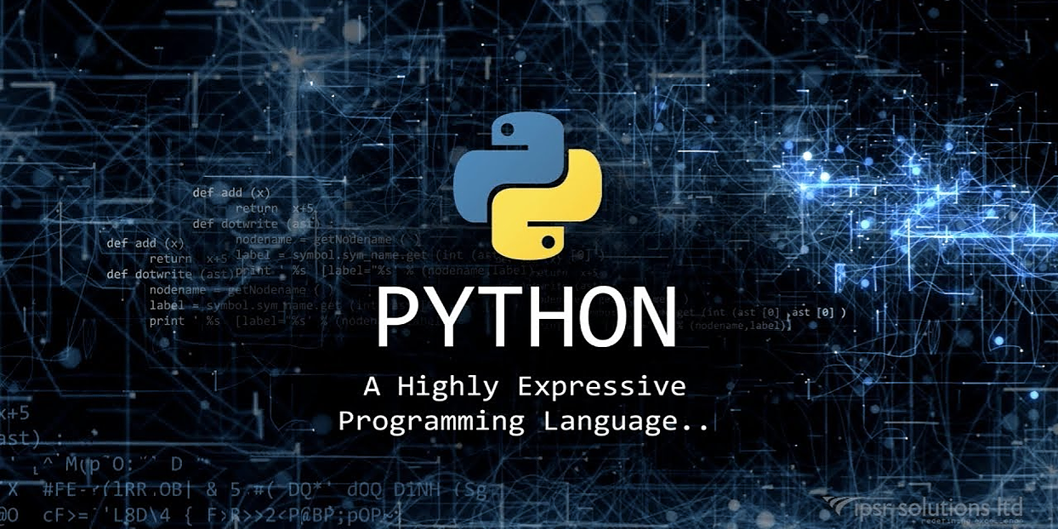
Python is an interpreted, object-oriented, high-level programming language with dynamic semantics. Its high-level built in data structures, combined with dynamic typing and dynamic binding, make it very attractive for Rapid Application Development, as well as for use as a scripting or glue language to connect existing components together. Python's simple, easy to learn syntax emphasizes readability and therefore reduces the cost of program maintenance.

Python supports modules and packages, which encourages program modularity and code reuse.

The Python interpreter and the extensive standard library are available in source or binary form without charge for all major platforms, and can be freely distributed. Often, programmers fall in love with Python because of the increased productivity it provides. Since there is no compilation step, the edit-test-debug cycle is incredibly fast. Debugging Python programs is easy: a bug or bad input will never cause a segmentation fault. Instead, when the interpreter discovers an error, it raises an exception. When the program doesn't catch the exception, the interpreter prints a stack trace.

A source level debugger allows inspection of local and global variables, evaluation of arbitrary expressions, setting breakpoints, stepping through the code a line at a time, and so on. The debugger is written in Python itself, testifying to Python's introspective power.

On the other hand, often the quickest way to debug a program is to add a few print statements to the source: the fast edit-test-debug cycle makes this simple approach very effective.

OPENCV

OpenCV was started at Intel in 1999 by GARYBRADSKY and the first release came out in 2000.
VADIM PISAREVSKY joined GARY BRADSKYto manage Intel’s Russian software OpenCV team. In 2005, OpenCV was used on Stanley, the vehicle who won 2005 DARPA Grand Challenge. Later its active development continued under the support of Willow Garage, with GARYBRADSKY and VADIMPISAREVSKY leading the project. Right now, OpenCV supports a lot of algorithms related to Computer Vision and Machine Learning and it is expanding day-by-day.
Currently OpenCV supports a wide variety of programming languages like C++, Python, Java etc and is available on different platforms including Windows, Linux, OS X, Android, IOS etc. Also, interfaces based on CUDA and OpenCL are also under active development for high-speed GPU operations.
OpenCV-Python is the Python API of OpenCV. It combines the best qualities of OpenCV C++ API and Python language.
Open CV(open source computer vision) is a library of programming functions mainly aimed at real-time computer vision . It enables the programmer to express his ideas in fewer lines of code without reducing any readability.
Compared to other languages like C/C++, Python is slower. But another important feature of Python is that it can be easily extended with C/C++. This feature helps us to write computationally intensive codes in C/C++ and create a Python wrapper for it so that we can use these wrappers as Python modules.
This gives us two advantages: first, our code is as fast as original C/C++ code (since it is the actual C++ code working in background) and second, it is very easy to code in Python. This is how OpenCV-Python works, it is a Python wrapper around original C++ implementation.
And the support of NUMPY makes the task more easier.
NUMPY is a highly optimized library for numerical operations. It gives a MATLAB-style syntax. All the OpenCV array structures are converted to-and-from NUMPY arrays. So whatever operations you can do in NUMPY, you can combine it with OpenCV, which increases number of weapons in your arsenal.
Besides that, several other libraries like SCIPY, MAPLOTLIB which supports NUMPY can be used with this.
So OpenCV-Python is an appropriate tool for fast prototyping of computer vision problems

APPLICATIONS
- Open CV application areas used:
- 2D and 3D feature tool kits
- Ego motion estimations
- Facial recognition system
- Gesture recognition system
- Human-computer interaction (HCI)
- Mobile robotics
- Motion robotics
- Object identification
- Segmentation and recognition
- Stereo psis stereo vision : depth perception from 2 camera
- Structure from motion (SFM)
- Motion tracking
- Augmented reality

HARDWARE AND SOFTWARE REQUIREMENTS
For this project, minimum hardware and software requirements are listed below:
Hardware Requirements:
Processor: ore(TM) i5-6200U CPU @ 2.30GHz
InstallIntel(R) Ced Memory (RAM): ore(TM) i5-6200U CPU @ 2.30GHz
System Type: 64-bit Operating System, x64-based processor

Software Requirements:
FrontEndTool :

Operating System : Windows 10

Screen Resolution : 1366 X 768

EXTRA MODULES TO IMPORT

- Date time
- Time
- Smtplib
- For adding an attachment,you need to install

- om email.mime.text import MIMEText
- from email.mime.multipart import MIMEMultipart
- from email.mime.image import MIMEImage
- from email.mime.base import MIMEBase

BACKGROUND SUBTRACTION

Background subtraction is a major preprocessing steps in many vision based applications. For example, consider the cases like visitor counter where a static camera takes the number of visitors entering or leaving the room, or a traffic camera extracting information about the vehicles etc. In all these cases, first you need to extract the person or vehicles alone. Technically, you need to extract the moving foreground from static background.
BackgroundSubtractorMOG2
It is a Gaussian Mixture-based Background/Foreground Segmentation Algorithm. It is based on two papers by Z.Zivkovic, "Improved adaptive Gausian mixture model for background subtraction" in 2004 and "Efficient Adaptive Density Estimation per Image Pixel for the Task of Background Subtraction" in 2006. One important feature of this algorithm is that it selects the appropriate number of gaussian distribution for each pixel. It provides better adaptibility to varying scenes due illumination changes etc.

Simple Mail Transfer Protocol

Simple Mail Transfer Protocol (SMTP) is an Internet standard for electronic mail (email) transmission. First defined by RFC 821 in 1982, it was last updated in 2008 with Extended SMTP additions by RFC 5321, which is the protocol in widespread use today.
Although electronic mail servers and other mail transfer agents use SMTP to send and receive mail messages, user-level client mail applications typically use SMTP only for sending messages to a mail server for relaying. For retrieving messages, client applications usually use either IMAP or POP3.
SMTP communication between mail servers uses TCP port 25. Mail clients on the other hand, often submit the outgoing emails to a mail server on port 587. Despite being deprecated, mail providers sometimes still permit the use of nonstandard port 465 for this purpose.
SMTP connections secured by TLS, known as SMTPS, can be made using STARTTLS.
Although proprietary systems (such as Microsoft Exchange and IBM Notes) and webmail systems (such as Outlook.com, Gmail and Yahoo! Mail) use their own non-standard protocols to access mail box accounts on their own mail servers, all use SMTP when sending or receiving email from outside their own systems.

Smtplib
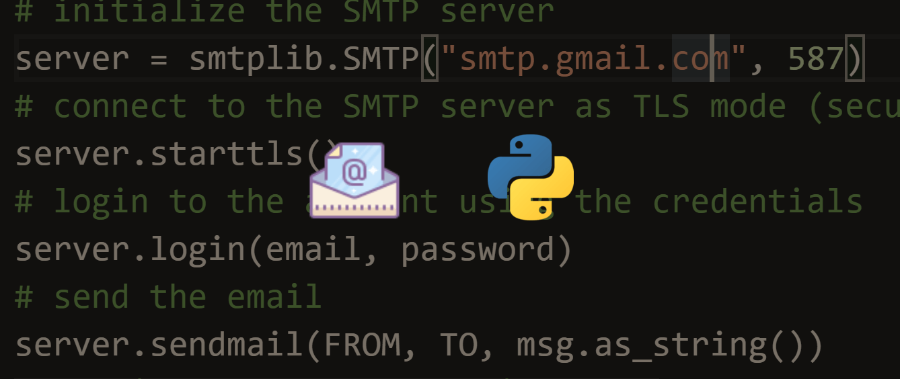

The smtplib module defines an SMTP client session object that can be used to send mail to any Internet machine with an SMTP or ESMTP listener daemon. For details of SMTP and ESMTP operation, consult RFC 821 (Simple Mail Transfer Protocol) and RFC 1869 (SMTP Service Extensions).
Class smtplib.SMTPLB([host[,port[,local_host name[,timeout]]]])
An SMTP instance encapsulates an SMTP connection. It has methods that support a full repertoire of SMTP and ESMTP operations. If the optional host and port parameters are given, the SMTP connect() method is called with those parameters during initialization. If specified, local_host name is used as the FQDN of the local host in the HELO/EHLO command. Otherwise, the local hostname is found using socket.getfqdn(). If the connect() call returns anything other than a success code, an SMTPConnectError is raised. The optional timeout parameter specifies a timeout in seconds for blocking operations like the connection attempt (if not specified, the global default timeout setting will be used). If the timeout expires, socket.timeout is raised.
For normal use, you should only require the initialization/connect, sendmail(), and quit() methods.

MOTION DETECTION CODE

import numpy as np
import cv2
import datetime
import time
import message2

cap=cv2.VideoCapture(0)
time.sleep(2)
fgbg=cv2.createBackgroundSubtractorMOG2()
count=0

while True:
ret,frame = cap.read()
text="UNOCCUPIED"
fgmask= fgbg.apply(frame)
gray = cv2.GaussianBlur(fgmask, (101, 101), 0)
ret,thresh= cv2.threshold(gray,25,255,cv2.THRESH_BINARY)
contours,hierarchy= cv2.findContours(thresh,cv2.RETR_EXTERNAL,cv2.CHAIN_APPROX_SIMPLE)
if (len(contours)!=0 and count<20):
if count>10 and count <20:
imgname="screen{}.png".format(count-10)
cv2.imwrite(imgname,frame)
if count ==19:
message2.message()
count=count+1
for cnt in contours:
if cv2.contourArea(cnt) < 10000:
continue
x,y,w,h = cv2.boundingRect(cnt)
cv2.rectangle(frame,(x,y),(x+w,y+h),(0,255,0),2)
text="OCCUPIED"
cv2.putText(frame, "Room Status: {}".format(text), (10, 20),cv2.FONT_HERSHEY_SIMPLEX, 0.5, (0, 0, 255), 2)
cv2.putText(frame, datetime.datetime.now().strftime("%A %d %B %Y %I:%M:%S%p"),(10, frame.shape[0] - 10), cv2.FONT_HERSHEY_SIMPLEX, 0.35, (0, 0, 255), 1)
cv2.imshow('Security Feed',frame)
k=cv2.waitKey(30) & 0xFF
if k==27:
break
cap.release()
cv2.destroyAllWindows()

USE CASE DIAGRAM

In this we will build a program that will detect the motion using opencv and python and notify the owner about the activity through a mail using gmail.
The video will be captured through web camera. The program will also click some pictures of the activity and send a picture with an alert mail as attachment to the mail id of the owner provided.
The other pictures of the activity are stored in a folder in the system on which the program is executing.

FLOW CHART USING PIR
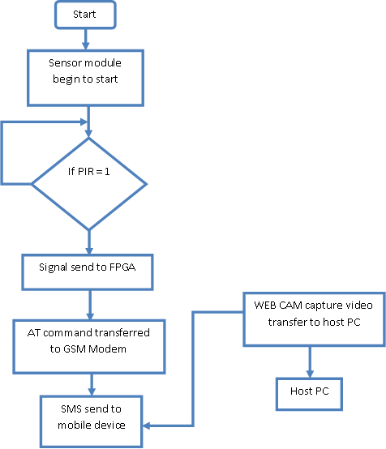

CONCLUSION

The software development is never completed. There is always a need for modification. There could have been other approaches to implement the system. I have tried to my level best to make the system an interactive as possible. The developed system is flexible and changes whenever can be made easy.

Hereby I came to an end of my project motion detection. This project gives an idea to detect the motion thus project can be used any where either at home or offices. This cost efficient.thus by this attempt of this circuit can be used as protecting device and can be used for security also. It can be used as a kind of antitheft device.It is very much cost efficient and can be used easily and efficientlty.

